NOOS annual report 2018

Member report – CEFAS
November 2018
Country | UK
Institution | Centre for Environment Fisheries and Aquaculture Research
Observations  Status and new initiatives | - WaveNet  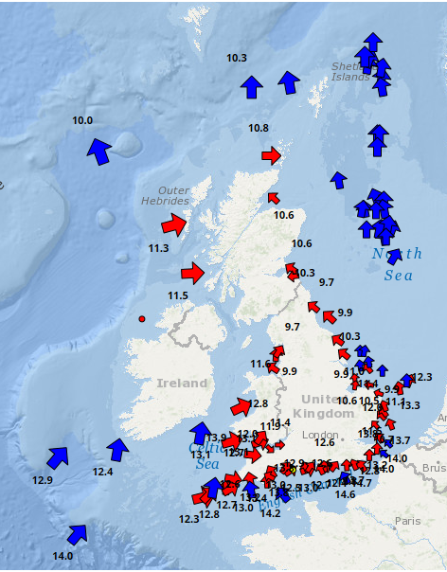  Figure 1 – Snapshot of wave (red arrow) and wind (blue arrow) direction and temperature (labels) from WaveNet website during November 2018.  Figure 1 shows the extent of WaveNet as of Autumn 2018. Virtually all public and commercial real-time wave feeds have been gathered together in the WaveNet system applying consistent QA/QC procedure on a nationwide scale. This combines data from the Oil and Nuclear Industries as well as some of the renewables sector in addition to the publicly funded buoys from the UKMO (K series), Irish Buoys (M series), CCO (Channel Coastal Observatory) and Cefas’ Buoys operated on behalf of UK Coastal Flood Forecasting Service.  - SmartBuoy  Cefas continues to operate 4 SmartBuoys at Liverpool Bay, West Gabbard, Warp and Dowsing sites serviced on a 3-monthly basis. The platforms continue to be testing sites for novel sensors including 3- axis accelerometers and micro nutrient sensors (NOC). The buoys continue to be a key part of the UK’s evidence base for a number of EU Directives.  - There have been 59 published peer reviewed publications using SmartBuoy data from 2002 to date, plus 8 completed PhD theses and 2 current PhD students using SmartBuoy data.  - SmartBuoy data was fundamental to the recent UK OSPAR eutrophication assessment.  - In addition to meeting Defra monitoring requirements, SmartBuoy data have been used for validation of satellite products (e.g. the EU HIGHROC project and EUNOSAT project) and marine ecosystem models (e.g. Shelf Sea Biogeochemistry research programme), and providing in situ data for marine ecosystem research programmes (e.g. Shelf Sea Biogeochemistry research programmes).  - Both Smartbuoys and WaveNet measured some of the highest temperatures this year, since records began.  - Ferrybox  The underway Ferrybox system on the Cefas Endeavour continues to operate, collecting biogeochemical parameters including seawater pCO₂ and phytoplankton functional types with a flow cytometer (Cytosense). Additionally, marine litter is monitored with an automated underway sampler. A passive sampler system is fitted for ecotoxicology studies and a Plankton Imager analyser (PIA) has been installed. The ferrybox has also been monitoring pH using a state of the art ISFET sensor.  Work has been carried out to integrate a Cefas water sampler into the Ferrybox. This has been used to collect samples in the Celtic Sea and Western English Channel for the determination of inorganic nutrients and for phytoplankton species composition and abundance.  - Remotely Piloted Surface Vehicle  Cefas operate the Liquid Robotics Wave Glider Lyra which has been used on a number of research and proof of concept campaigns. Highlights include using satellite observations to determine the key location to take water samples on the Dogger bank during a harmful algal bloom; linking biogeochemistry sampling at SmartBuoy sites. This summer, Lyra was fitted with an autonomous fisheries acoustics system along with water quality sensors and undertook two successful missions as part of the NERC-Defra AlterECO campaign.  - Satellite Observations  Cefas is part of Defra’s Centre of Earth Observation Centre of Excellence (EOCoE) utilising a wide range of satellite products (ESA Sentinel) to monitor both the terrestrial and marine environments. Various projects are developing cross-cutting tools (DEFRA Single Platform, which is incorporating MEO-Ap), determining pressures (Marine AIS for Shipping Intensity maps, MCZ monitoring and Air Quality) besides determining the extent and duration of impacts (e.g. suspended sediment plumes from offshore Windfarms).  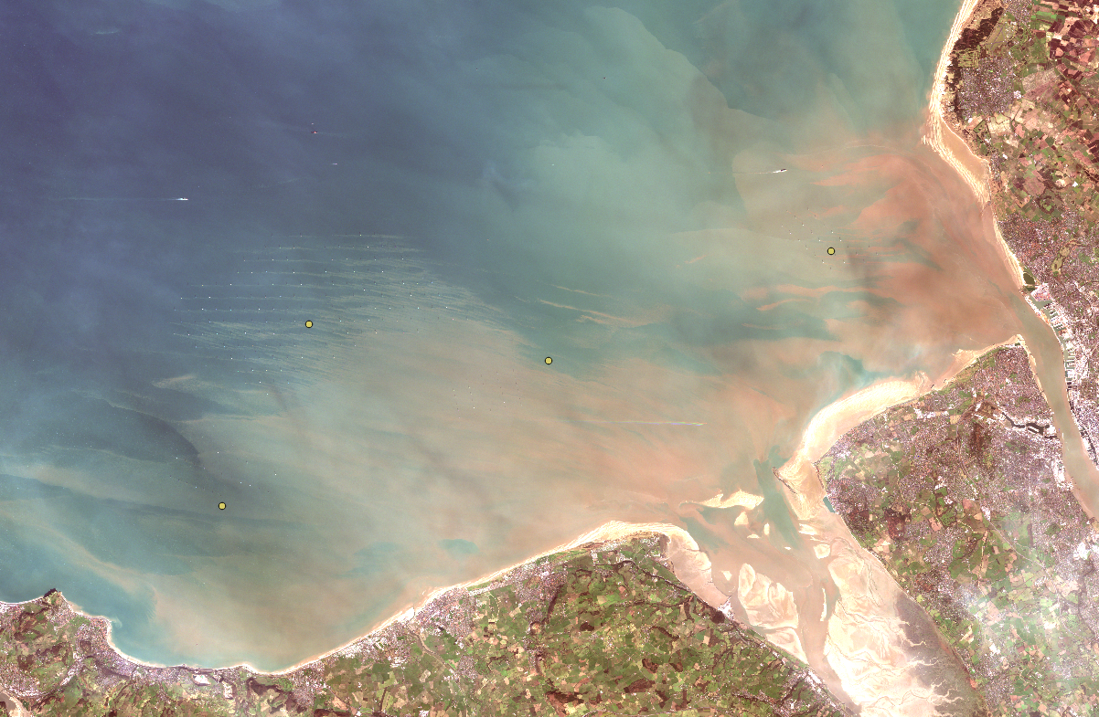  Figure 2 - Sentinel 2 Image of suspended sediment plumes from Offshore wind farms in Liverpool Bay.
Modelling  Status and new initiatives | Cefas continues to contribute to the EG (Environment Group) in Marine emergencies providing advice to Defra, MMO (Marine Management Organisation), JNCC (Joint Nature Conservation Committee) and FSA (Food Standards Agency) as well as the Coastguard. The trajectory modelling relies on flow fields from Copernicus and Cefas’ own high resolution Telemac model with river inputs. These provide the base data from which commercial products such as OSCAR and Chemmap provide the behavioural trajectories and budgets (utilising UKMO wind fields). Post incident monitoring is undertaken using the PREMIAM guidelines (https://www.cefas.co.uk/premiam.aspx?RedirectMessage=true).  Cefas also uses the developed Forensic Oceanography services to provide information to various Police authorities around the UK and the NCA (National Crime Agency). Advice on potential trajectories of Missing persons has been used to optimise police procedures to maximise the use of Police assets in order to get closure for the family. Also used in backtrack mode for narcotics and determine likely entry points for recovered bodies.  Cefas has developed an operational wave-forecasting model for offshore wind-farms in the North Sea using Tomawac and Telemac.  Development of a hydrodynamic model (Telemac 3D) to evaluate the impact of Combined Sewer Overflows (CSOs) in the Dart Estuary (Devon, SW England).  Updating (ongoing) of the 3D biogeochemical hindcast up to the present. These results are intended to be used as tools to complement and understand the variability of the in situ data in order to provide a more holistic assessment of the ecological processes, thus providing a mechanism to test the effectiveness of the monitoring programme and to improve the quality of assessments and increase the confidence associated with the assessment outcomes.
Dissemination  Status and new initiatives | In support of our commitment to open data access and open science, we have launched the Cefas Data Hub – an online portal allowing the public and UK businesses to explore, download and reuse the data for their own research (Open Government Licence terms and conditions apply).  Datasets available include many of our legacy datasets covering subjects such as fish, shellfish and plankton survey data from the 1980’s to the present day, records relating to MEDIN Marine Fisheries Data Archive Centre, water temperature, salinity, and sediment data from across the UK continental shelf.  Each month we are publishing more current data. Cefas has made significant progress in data processing of Ferrybox data and aims to provide data as netcdfs via the Cefas Data Hub in the next year. Work on conversion of chlorophyll fluorescence to chlorophyll concentration is ongoing. All data on the Cefas Data Hub is available to download, and also uses APIs for direct access.  The Cefas data hub page has been updated, and we hope to include data visualisation tools and highlight particular datasets regularly in future. The Cefas data hub is also one of the virtual access infrastructures for Jerico Next.  In addition to the wide range of data available on the Cefas Data Hub, the SmartBuoy data are available in NRT on the Cefas website and NOOS and EMODnet portals. Work is ongoing to make SmarrtBuoy post recovery QA’d data available as netcdfs on the Cefas Data Hub.  Wave data can be downloaded from the Cefas WaveNet website for certain buoys only. This single data source provides the best possible data quality assurance for downloaded wave data. Data downloads are recorded as this constitutes one of the key KPIs of the project funder
Relevant national projects | CEFMAT - The old EMECO tool has been replaced by a new assessment tool ‘CefMAT’ that is significantly more robust and secure, and can produce a wider range of assessments using a wide range of parameters. The assessment tool can generate data products that correspond to MSFD and OSPAR indicators assessment outputs.  AlterECO exploring the differences between Fisheries acoustic sounders on a glider and that on the Cefas Endeavour.  Marine Ecosystem Connections.  Shelf Seas Biogeochemistry – this project is ending, and has produced a wide range of science outputs, particularly relating to carbon cycling. Cefas is continuing our science using the extensive data collected from the 2014-2015 SSB campaign. This includes 2 SmartBuoys, FerryBox, and 5 seabed lander locations.
Relevant International projects | JERICO-NEXT – Cefas are involved in the JERICO-NEXT project –leading WP6 on virtual access to data and services. We are also working in JRAP 1 on innovative technologies for determination of phytoplankton diversity and biomass.  DCS4COP is a follow on to the HighROC project processing satellite data for chlorophyll and SPM particular, with several use cases, e.g. chlorophyll for MSFD assessments.  Eunosat – this project is working to align eutrophication indicator measurements and assessment methods to improve the coherence and consistency of GES assessments in the North Sea, with a particular focus on chlorophyll.
Additional information

