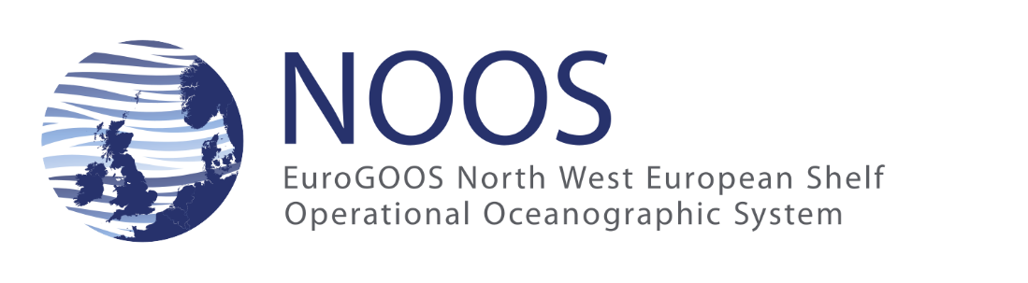

NOOS Annual meeting 2021, 3 & 9 Dec 2021, Virtual
Minutes of the business meeting

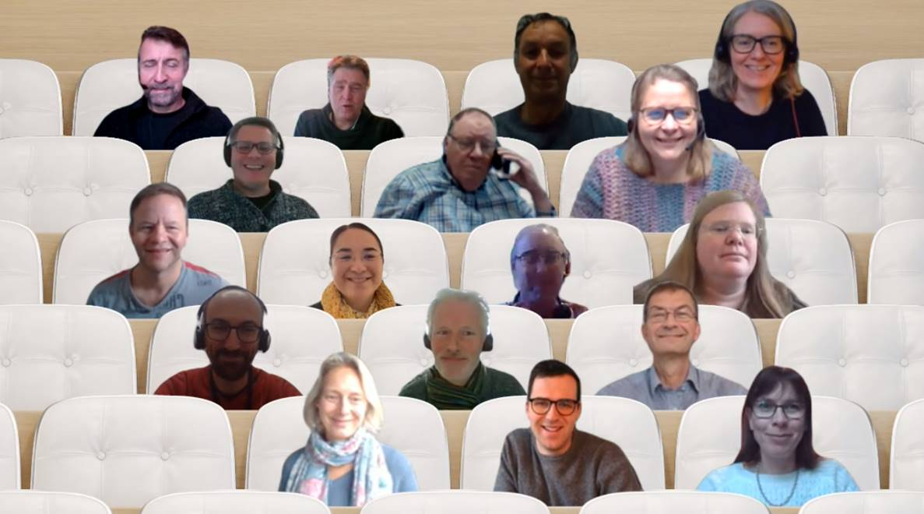

Contents
2. Attendance list 2
3. Introduction 5
4. Agenda of the Business meeting 5
1. Decisions 5
New NOOS Logo 5
Updating NOOS Memorandum of understanding 6
5. Steering committee 7
6. Action plan for 2022 7

Attendance list
3 Dec 2021
Name | Institute
Legrand Sébastien (Chair) | RBINS
Baetens Katrijn | RBINS
Blackford Jeremy | PML
Borst Kees | RWS
Dick Stephan | BSH
Erik Campo | BSH
Gautier Caroline | Deltares
Gomez Breogan | UK Met Office
Gorringe Patrick | SMHI
Haaring Pieter | RWS
Hansen Carsten | FCOO, Met-Oc
Herklotz Kai | BSH
Huess Vibeke | DMI
Korabel Vasily | DMI
Lepers Ludovic | RBINS
Lips Inga | EuroGOOS
Nielsen Jacob | DMI
Panteleit Tabea | BSH
Perez-Gonzales Irene | BSH
Philippart Marc | RWS
Saulter Andrew | UK Met Office
Schulz Johannes | Hereon
Söderqvist Johan | FCOO, Met-Oc
Tamm Susanne | BSH
Verboeket Rik | RWS
Voynova Yoana | Hereon (ex-HZG)
Wehde Henning | IMR
Wilms Mayumi | BSH
Zijderveld Annette | RWS

9 Dec 2021
Name | Institute
Legrand Sébastien (Chair) | RBINS
Baetens Katrijn | RBINS
Blackford Jeremy | PML
Borst Kees | RWS
Dick Stephan | BSH
Erik Campo | BSH
Gautier Caroline | Deltares
Gomez Breogan | UK Met Office
Hansen Carsten | FCOO, Met-Oc
Lepers Ludovic | RBINS
Lips Inga | EuroGOOS
Nielsen Jacob | DMI
Panteleit Tabea | BSH
Perez-Gonzales Irene | BSH
Philippart Marc | RWS
Saulter Andrew | UK Met Office
Söderqvist Johan | FCOO, Met-Oc
Tamm Susanne | BSH
Verboeket Rik | RWS
Voynova Yoana | Hereon (ex-HZG)
Wehde Henning | IMR
Wilms Mayumi | BSH
Zijderveld Annette | RWS

Excused : MDK, MET Norway

Introduction
Due to the autumn upsurge of the COVID-19 pandemic, the NOOS annual meeting 2021 has been organized as 2 virtual half day sessions on the 3rd and 9th of December 2021. The main objective of the meeting was to present and discuss the recent developments made by the NOOS community. The list of presented topics as well as the presentations slides are available on the NOOS website: http://noos.eurogoos.eu/documents/annual-meetings/annual-meeting-2021-virtual/
As usual, the NOOS annual meeting ended with the General Assembly meeting, also called the formal NOOS business meeting. This report is the minutes of this meeting. It mainly records the decisions and presents the priority list for the NOOS work program 2022.

Agenda of the Business meeting
The Assembly approved the following agenda:
- Summary of possible actions to draft the NOOS work program 2022
- Formal votes:
  - new NOOS logo
  - update NOOS Memorandum of Understanding
  - NOOS Working group
- new member(s)
- Election of 1 steering group member
- NOOS annual meeting 2022
- AOB

Decisions

New NOOS Logo
In March 2021, EuroGOOS office suggested to update the NOOS logo in order to align the visual identity of all EuroGOOS ROOSes, Working Groups and Task Teams with the main EuroGOOS logo. To this purpose, the office made a first proposal:

Via a survey, the NOOS community has been able to comment this proposal in April/May 2021. Based on these feedbacks, the Office slightly modified its proposal and the Steering Committee, with the help of Marc Philippart, developed two other proposals.
During the business meeting, the general assembly has been asked to make a formal choice between these 4 options:
- Option 1: the current NOOS logo
- Option 2: the logo proposal developed by the EuroGOOS office
- Option 3: A first alternative logo developed to maximize the usage of the logo area
- Option 4: A second ‘fancier’ alternative logo
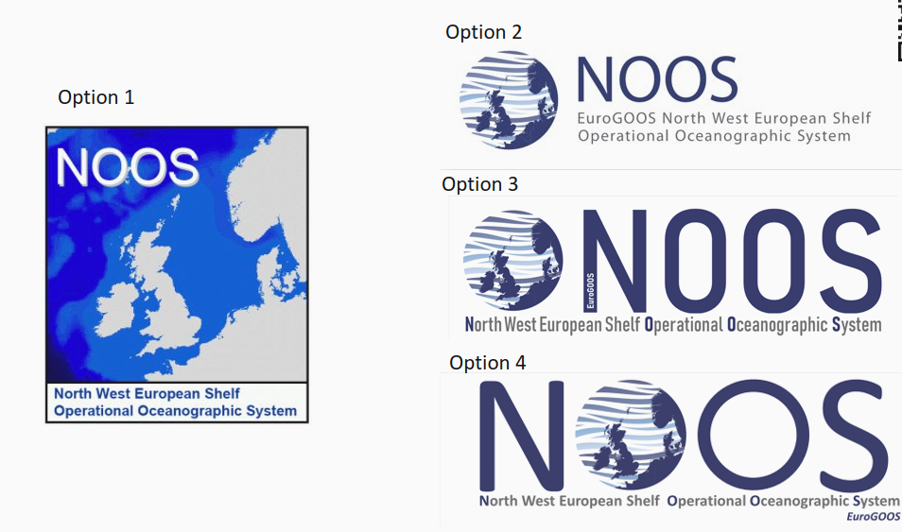
The result of a first vote plebiscites option 2:
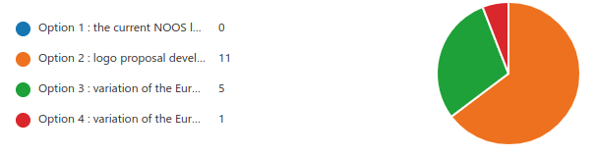

After a second row of discussions, the NOOS General Assembly unanimously adopt the office proposal (option 2)
This logo is to be used from now on. You can download the logo from the NOOS website : http://noos.eurogoos.eu/other-documents/

Updating NOOS Memorandum of understanding
The current version of NOOS MoU dates back from 2002. The General Assembly unanimously agreed to establish a drafting committee in order to update the NOOS MoU. The steering committee is tasked to established this drafting committee with the objective to present a new NOOS MoU proposal at the next general assembly.

NOOS Working Group on Offshore Renewable Energy (ORE)
The General Assembly unanimously agreed to establish a new NOOS working group on Offshore Renewable Energy.
The first task of this new working group will to draft their Terms of Reference based on the report of the NOOS ORE initiative presented by Johannes Schulz-Stellenfleth (Hereon). The Assembly General expects that Johannes will accept to lead the working group.

NOOS working group on model and model validation
At the Annual Meeting 2015, the NOOS modelling working group has been renamed the NOOS working group on model validation. Unfortunately, this working group has never defined any specific activities. Because this WG is partly redundant with the MME working group, Sébastien Legrand therefore suggested to withdraw it.
After discussion, the General Assembly tasked the steering committee to study the possibility to re-energize the working group, either by nominating a new leading scientist or by refreshing the Working Group ToRs. For instance, during the discussion, it has been suggested that the working group could be a forum where specific model intercomparison could take place (e.g. a different topic every year, starting with the bottom drag coefficient…). If re-energizing the working group is not possible, the steering committee should then try to merge it with the MME working group. The withdraw option may only be considered as the ultimate option.

NOOS ambassadors
In order to improve the integration between the different EuroGOOS working groups, task teams and ROOSe, the NOOS annual meeting 2017 decided to establish the role of NOOS ambassadors, i.e. a people in charge of making the (2-way) liaison between NOOS and another EuroGOOS sub-body.
The General Assembly reviewed the list of NOOS ambassadors:
- DataMEQ: Susanne Tamm (BSH) ​
- SAWG: Henning Wehde (IMR) and Sébastien Legrand (RBINS)​
- Coastal WG: Sébastien Legrand (RBINS)​
- Tide gauge TT: Anna von Gyldenfeldt (BSH) and Martin Verlaan (Deltares)​
- Ferry box TT: Yoana Voynova (Hereon)​
- TPWG : Henning Wehde (IMR)
The General Assembly also discussed potential ambassador candidates:
- HF Radar TT: Jochen Horstmann (Hereon)​
- Biological Observation WG: Veronique Creach (CEFAS)
- Fixed platform TT : Kai Herklotz (BSH)
- ARGO TT : Birgit Klein (BSH)
- Glider TT : Holger Brix (Hereon)
The steering committee is tasked (1) to invite the identified persons to become NOOS ambassadors and (2) to organize a meeting with all ambassadors to redefine the role of ambassadors and to prepare the next EuroGOOS integration workshop (May 2022).
It is expected that, from now on, the ambassadors will have to make a short report at each NOOS annual meeting.

Steering committee
In 2020-2021, the NOOS steering group was made of: ​
- Sebastien Legrand (chair, re-appointed 2020)​
- John Siddorn (2017)​
- Susanne Tamm (2018)​
- Johan Söderqvist (2019)​
- Jacob Nielsen (re-appointed 2020)​
- Annette Zijderveld (2020)
John Siddorn’s term ended in 2021, a new steering group member could have been elected. Unfortunately, no candidate was nominated.
The steering committee for 2022 is made of
- Sebastien Legrand (chair, re-appointed 2020)​
- Susanne Tamm (2018)​
- Johan Söderqvist (2019)​
- Jacob Nielsen (re-appointed 2020)​
- Annette Zijderveld (2020)
Susanne Tamm’s mandate ending in 2022, election for 2 steering committee members at the NOOS annual meeting 2022. Susanne is of course re-eligible for a new mandate.
In 2022, the steering committee will meet once a month (usually the second Tuesday of the month). Brief minutes of this meeting will be uploaded to the NOOS website.

Action plan for 2022
Action Name | Description | Action leader | Deadline
2021-01 | Preparing a project proposal to be submitted to the 1st call of the interreg North Sea.  https://northsearegion.eu/about-the-programme/programme-news/interreg-north-sea-2021-2027-first-call-open/  The main topic of the proposal should deal with ocean renewable energy but specific actions should be foreseen for all NOOS working groups | Steering Committee | Expression of interest to be submitted by 7th of March; full project by April 22nd
2021-02 | NOOS MoU :  - Steering Committee in charge to set up a drafting committee (ASAP in early 2022)  - Steering committee will organize the first meeting of the drafting committee during which a chair will be elected.  - The chair of the drafting committee will drive the process until the submission of the revised version of the MoU | Steering Committee + chair of the drafting committee | Before summer break 2022
2021-03 | NOOS Strategy :  - Steering committee is in charge to draft the NOOS strategy document  - Once ready, Marc Philippart offers to realize a short movie to illustrate the strategy | Steering Committee | Before summer break 2022
2021-04 | NOOS ambassadors :  - The steering committee will invite Jochen Horstmann (Hereon), Veronique Creach, Kai Herklotz (BSH) , Birgit Klein (BSH) and Holger Brix (Hereon) to become NOOS ambassadors  - The steering committee will organize a specific meeting with all ambassadors to beter define their role and prepare the EuroGOOS integration meeting () | Steering Committee | May 2022
2021-05 | Steering committee must identify possible services that NOOS could deliver to its members and stakeholders in order to increase its visibility:  Examples :  - Contributing to the Copernicus Ocean State Report  - Setting up a unified catalogue with all NOOS members products and data sets  - Kees Borst suggested to advertising OSPAR on NOOS hindcast products and think to re-established quarterly bulletin (as NOOS did in past with the NORSEPP reports)  - … | Steering Committee + all | Annual meeting 2022
2021-06 | MME working group work program:  - Using the NRT MME warning system as indicator of product incident​  - Expending the MME system to BGC forecast -> call of model providers​  - Developing other uncertainty estimates based on NRT and MYR MME results​  - Displaying again the observation in the validation timeseries | MME working group (leader : Panteleit Tabea, BSH) | Annual meeting 2022
2021-07 | Work plan for the working group on sealevel and waves:  - The 7 sub-groups must continue working on their respective topics  - Further developments in the BMA systems includes adding new locations, distributing the BMA forecast or developing a verification dashboard.  - The current data flow should be put on the NOOS website  - Possible activities:  - How BMA forecast gives access to forecast uncertainty?  - Inter-comparison of the roughness length and/or bottom drag coefficient in the different models | Sealevel and waves WG (leader : Marc Philippart, Jacob Nielsen and Caroline Gautier) | Annual meeting 2022
2021-08 | Work plan for the ORE working group  - Developing ToRs of the working group : Which format? Which scope? Which members? Which leading scientists?​  - At least one meeting in spring 2022  - The ORE WG should consider the long term impact on ecosystems (Luca Van Duren from Deltares)​  - The ORE WG should establish contact with the North Sea Energy Cooperation​  - The ORE WG should consider how to incorporate Wind Farms in our respective models to keep reliable forecasting skills, especially in case of extreme events​ | ORE WG (leader : TBD + Johannes Schulz) | Annual meeting 2022
2021-09 | Work plan for the river WG:  - River is a hot topic: Interest to connect the NOOS WG with​ the river activities of the EuroGOOS Coastal WG​, with the newly established BOOS river WG​ and maybe with the OSPAR ICGMO?​  - Impact on river runoff of​ inland floodings​ and storm surge barriers​ | River WG (leader : Jacob Nielsen) | Annual meeting 2022
2021-10 | Work plan for the NOOS working group on drift:  - Finalizing the article on NOOS-Drift  - Organizing a meeting with all the historical WG members | NWGD (leader : Sébastien Legrand) | Annual meeting 2022
2021-11 | Work plan for the NOOS data portal working group:  - put in production the final version of the data portal and phase-out of the old portal to have a single portal again​  - develop description/manuals of the new portal ​  - Rivers data for CMEMS : which metadata? Which format? Which variables? Which stations? (hundreds of stations in England) | NOOS data portal WG (leader : Susanne Tamm) | Annual meeting 2022

